PBT205 Assessment 1 – Trading System

Item | Detail
Scope | Trading system: exchange (C1), sendOrder (C2), last-price GUI (C3) and integration test (C4)
Middleware | RabbitMQ 3.13.7 on Erlang 26.2.5.16, Docker image rabbitmq:3-management
Language | Python 3 with the pika AMQP client (version 1.3 or later, below 2); the GUI server uses only the standard library
Test run | 19 October 2026, 2:23 to 2:33 am local time, on Windows with three VS Code terminals named EXCHANGE, GUI SERVER and TRADERS

1. Technical requirements analysis
Area | The brief requires | Our decision | Code and evidence
Middleware | RabbitMQ, launched with Docker | One rabbitmq:3-management container. AMQP on port 5672, management UI on port 15672 | docker-compose.yml; Figures 5 and 6
Topics | Two topics, orders and trades | Both are routing keys on one topic exchange, pbt205. sendOrder publishes to orders; the exchange consumes orders and publishes to trades; the GUI subscribes to both | common/broker.py; Figure 5
Delivery model | Every interested program receives each message | Each subscriber declares its own exclusive, auto-delete queue and binds it to the topic (publish/subscribe) | subscribe() in common/broker.py; Figure 6
sendOrder protocol | Username, endpoint, SIDE, QUANTITY (fixed at 100), price; submit the order and exit | Arguments are validated before connecting. Any quantity other than 100 is refused. Publisher confirms make the program wait until the broker accepts the order, then it exits | task2-trading/send_order.py; Figure 3
Exchange protocol | Endpoint only | exchange.py <endpoint>. The endpoint can be a port, host:port or a full AMQP URL | exchange.py, endpoint_to_url(); Figure 2
Serialisation | Team's choice | UTF-8 JSON with content_type: application/json. Price is a JSON number (double), orderId is unique, ts is ISO-8601 UTC | publish() in common/broker.py; order and trade fields in send_order.py and exchange.py
Integration | One exchange, many traders with unique identifiers | The exchange is the only consumer of orders. A second instance would match the same orders twice, so only one may run | exchange.py; Figure 4
Matching and boundaries | Limit orders; match when the price is acceptable to both sides | A BUY matches a resting SELL when buy price ≥ sell price, so equal prices trade. The trade runs at the resting order's price. Best price wins, then earliest arrival. A matched order leaves the book | task2-trading/order_book.py; Figures 2 and 3
Invalid input | Not specified | sendOrder rejects a bad side, quantity or price. The exchange re-checks every message and logs rejects. Malformed JSON is dropped, never crashing a program | send_order.py, exchange.py, broker.py; Figure 3
GUI concurrency | Show live trades while the user can also place orders | pika's BlockingConnection must be used from one thread only (Pika, n.d.). The listener thread owns its connection; each order from the browser opens a short-lived connection | task2-trading/gui_server.py
How the requirements relate
- Limit orders and the resting-price rule. Because every order carries a price, the trade price always comes from the book. No market-order price search is needed.
- One exchange, one consumer. RabbitMQ delivers orders to one consumer in one arrival order, so the order book needs no locking. The cost is a single point of failure.
- Quantity fixed at 100. Every match fills both orders completely. A matched order simply leaves the book, with no partial fills to track.
- Shared helper. Every program builds messages with the same JSON fields and declares pbt205 through common/broker.py. A program that declared it differently, for example as durable, would be refused by RabbitMQ.
- Queues exist only while a subscriber is connected. An order published before the exchange subscribes is lost, so the exchange must be running before traders send orders.

2. Prototype design and creation
The prototype is four small Python programs that share one RabbitMQ helper. They talk only through the pbt205 topic exchange; no program calls another directly.
Figure 1
Message Flow
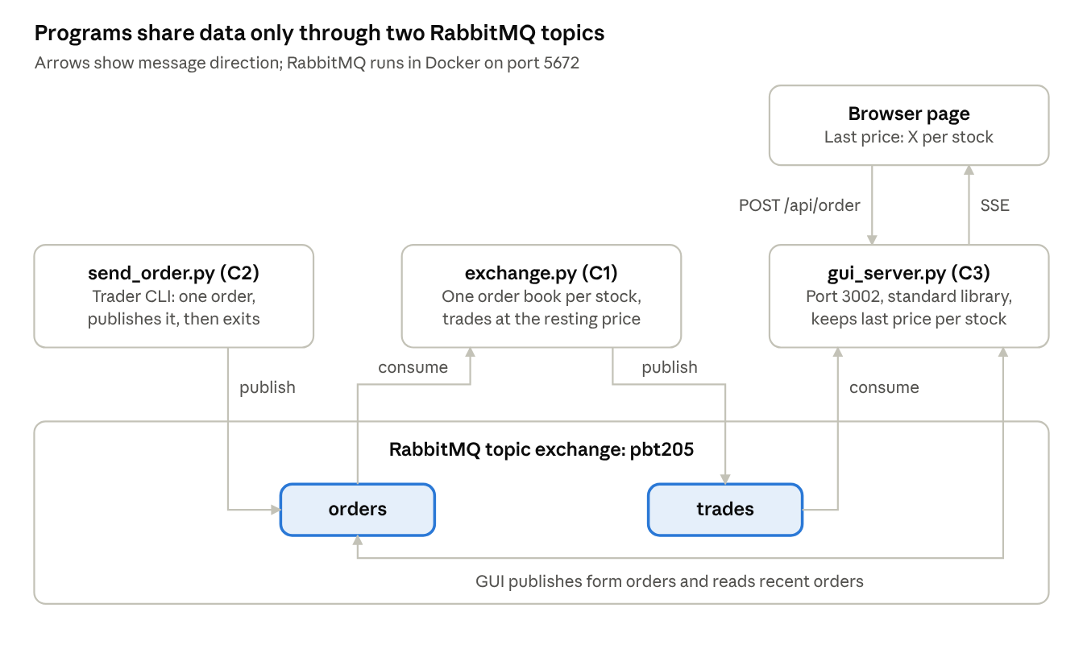
Note. send_order.py and the GUI form publish to orders. The exchange consumes orders and publishes each match to trades. The GUI server reads both topics and pushes updates to the browser over Server-Sent Events.
send_order.py (C2). Takes a username, endpoint, side, quantity and price, plus an optional stock symbol (default XYZ). It validates the arguments, connects, turns on publisher confirms and publishes one order to orders. It then prints a line such as Sent BUY 100 XYZ @ 10.5 as alice and exits.
exchange.py (C1). Subscribes to orders and keeps one OrderBook per stock symbol. For each valid order it prints an ORDER line. It then either publishes a trade to trades and prints TRADE, or adds the order to the book and prints a BOOK snapshot.
order_book.py (C1). Holds the buy list (bids, highest price first) and the sell list (asks, lowest price first), each tie-broken by arrival sequence. For each new order:
- Take the best opposite order: the lowest ask for a BUY, the highest bid for a SELL.
- If the price is acceptable (BUY ≥ ask, or SELL ≤ bid), remove that order and return a trade at its price.
- Otherwise add the new order to its own list, sorted by price, then arrival.
Sorted lists were chosen because they are clearly correct at assignment scale; insertion is O(n). A heap is the upgrade path if volume grows.
gui_server.py and gui/index.html (C3). A Python HTTP server on port 3002 serves one page. A background thread subscribes to trades and orders and keeps the last price per stock, plus the 50 most recent trades and orders. Each browser holds a Server-Sent Events stream (/api/stream), so the "Last price: X" tile updates as soon as a trade arrives (MDN Web Docs, n.d.). A form posts to /api/order, which validates the order and publishes it with quantity 100, just as sendOrder does.
Multiple stocks (Final Product extension). Every order carries a symbol. The exchange creates a new book the first time it sees a symbol, and the GUI adds a tile for each traded symbol. Adding a stock needs no code change.
common/broker.py (shared helper). Provides connect, publish, subscribe and close. Topic names and the exchange declaration live in one place, so every program declares pbt205 identically.
To run the prototype:
docker compose up -d
python task2-trading/exchange.py 5672
python task2-trading/gui_server.py 5672
python task2-trading/send_order.py alice 5672 BUY 100 10.50

3. Testing and evidence
All eleven checks passed. Each one is backed by a screenshot in docs/screenshots/, and Figure 7 shows the automated integration test.
The manual run used three terminals (EXCHANGE, GUI SERVER, TRADERS) and the RabbitMQ management UI. The manual programs were then stopped and scripts/test_trading.py was run, because it starts its own exchange.
# | Test | Expected | What the screenshot shows | Result
1 | C1: alice BUY 100 @ 10.50, then bob SELL 100 @ 11.00 | Both orders rest; no trade | BOOK XYZ {"bids":["alice@10.5"],"asks":["bob@11"]}, no TRADE line | Pass
2 | C1: carol SELL 100 @ 10.00 | Trade at the resting price, 10.50 | TRADE #1 XYZ 100 @ 10.5 (buyer alice, seller carol) | Pass
3 | C1: dave BUY 100 @ 11.50 | Trade with bob at 11.00 | TRADE #2 XYZ 100 @ 11 (buyer dave, seller bob) | Pass
4 | C1: dave BUY 100 @ 11.50 again, no sell orders left | Order rests as a bid | BOOK XYZ {"bids":["dave@11.5"],"asks":[]} | Pass
5 | C2: every valid send_order call | Prints Sent … and returns to the prompt | Five Sent lines, prompt back after each | Pass
6 | C2: eve BUY with quantity 50 | Refused before connecting | QUANTITY is fixed at 100 for this assignment and the usage line; nothing from eve in EXCHANGE | Pass
7 | Multi-stock: frank BUY and gina SELL 100 ABC @ 5 | ABC trades in its own book; XYZ unchanged | TRADE #3 ABC 100 @ 5 (buyer frank, seller gina); dave's XYZ bid still rests | Pass
8 | C4: several traders on one exchange | Orders from 5 or more traders, handled in arrival order | 7 orders from 6 traders (alice, bob, carol, dave, frank, gina), 3 trades | Pass
9 | RabbitMQ: topic exchange | pbt205, type topic, non-durable | Listed as topic with no D (durable) flag | Pass
Figure 2
Order Book After Two Orders That Do Not Cross
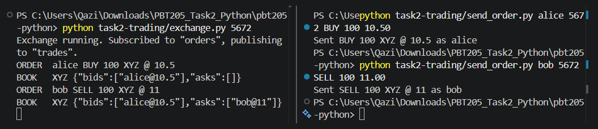
Note. alice bids 10.50 and bob asks 11.00, so both orders rest and no TRADE line appears. Left: EXCHANGE terminal; right: TRADERS terminal. Cropped from docs/screenshots/C1-exchange-order-book.png, captured 19 October 2026, 2:23 am.
Figure 3
Trades at the Resting Price and a Rejected Quantity
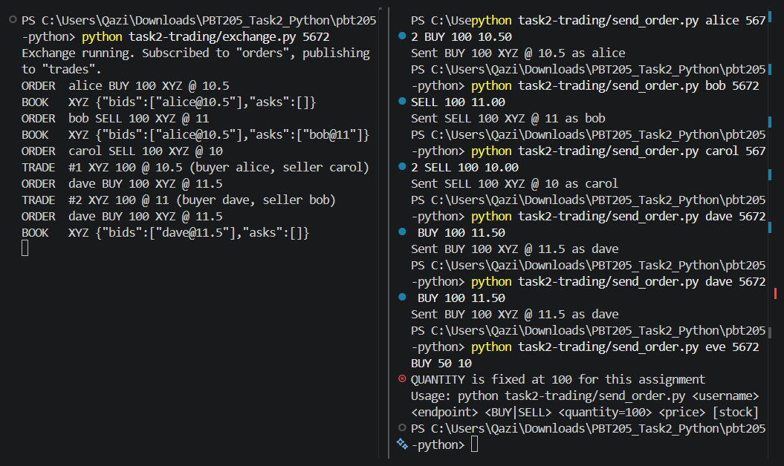
Note. TRADE #1 runs at alice's 10.50, not carol's 10.00. TRADE #2 runs at bob's 11.00, not dave's 11.50. eve's quantity of 50 is refused in TRADERS and never reaches the exchange. Cropped from docs/screenshots/C2-sendorder.png, 2:27 am.
Figure 4
Several Traders and a Second Stock on One Exchange
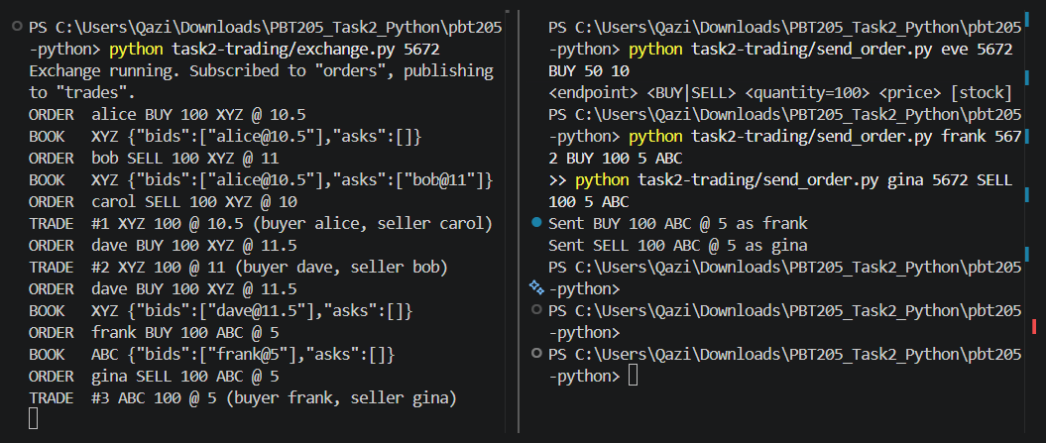
Note. Seven orders from six traders produce three trades. frank and gina's ABC orders trade at 5.00 in their own book while dave's XYZ bid stays untouched. Cropped from docs/screenshots/C4-several-traders.png, 2:30 am.
Figure 5
The pbt205 Topic Exchange in the RabbitMQ Management UI
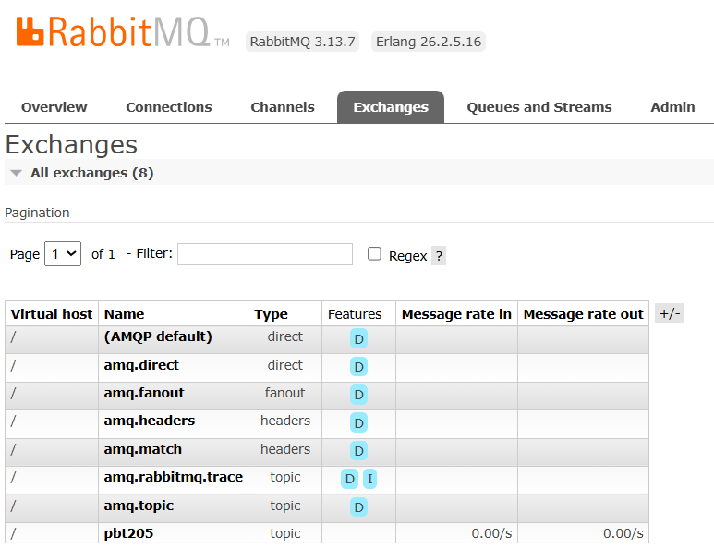
Note. pbt205 is type topic and has no D (durable) feature, matching durable=False in common/broker.py. Page localhost:15672/#/exchanges, refreshed 2026-10-19 02:31:10. Cropped from docs/screenshots/C4-rabbitmq-exchange.png.
Figure 6
One Private Queue per Subscription
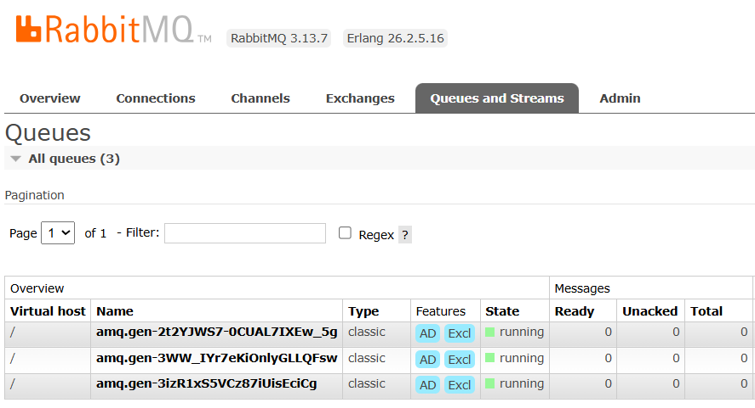
Note. Three server-named queues, each AD (auto-delete) and Excl (exclusive). The exchange subscribes to orders; the GUI server subscribes to trades and orders. No messages are waiting (Ready 0). Page refreshed 2026-10-19 02:31:48. Cropped from docs/screenshots/C4-rabbitmq-queues.png.
Figure 7
Automated Integration Test Output
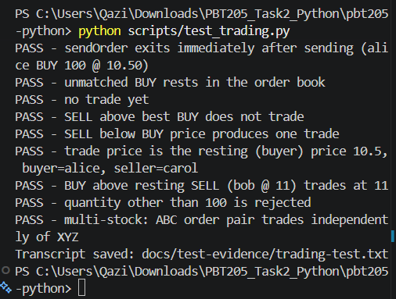
Note. scripts/test_trading.py starts its own exchange and real send_order processes, then prints one PASS or FAIL line per check. Every line shown is PASS. Cropped from docs/screenshots/C4-test-output.png, 2:33 am.
Figure 8
Exchange Terminal Before the First Trade
Note. The same capture as Figure 2 (2:23 am): alice's bid and bob's ask are resting and no TRADE line has printed yet. The first trade, TRADE #1 XYZ 100 @ 10.5, appears in Figure 3. Cropped from docs/screenshots/C1-exchange-trade.png.
Figure 9
The pbt205 Topic Exchange During the Manual Run
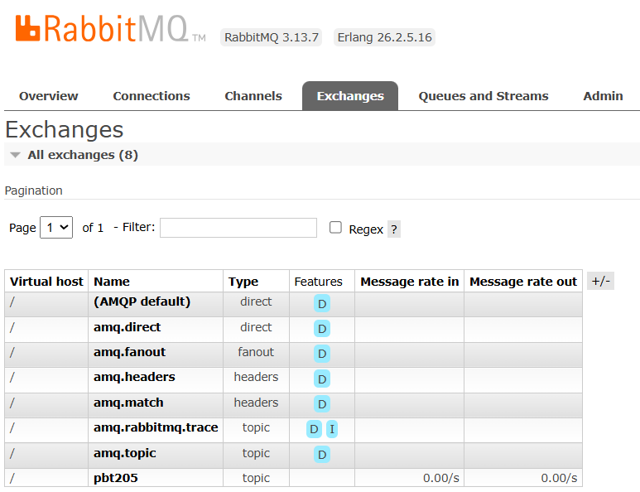
Note. Page refreshed 2026-10-19 02:26:04, in the middle of the manual run and five minutes before Figure 5. pbt205 is already listed as a topic exchange with no D (durable) flag. Cropped from docs/screenshots/C3-gui-last-price.png.
Figure 10
Subscriber Queues During the Manual Run
Note. Page refreshed 2026-10-19 02:29:32. The same three queue names appear in Figure 6 at 02:31:48, so the exchange and GUI server kept the same queues between the two captures. Cropped from docs/screenshots/C3-gui-multi-stock.png.

References
Harris, L. (2003). Trading and exchanges: Market microstructure for practitioners. Oxford University Press.
MDN Web Docs. (n.d.). Using server-sent events. Mozilla. https://developer.mozilla.org/en-US/docs/Web/API/Server-sent_events/Using_server-sent_events
Pika. (n.d.). Pika documentation. https://pika.github.io/pika/latest/
RabbitMQ. (n.d.-a). Authentication, authorisation, access control. https://www.rabbitmq.com/docs/access-control
RabbitMQ. (n.d.-b). RabbitMQ tutorial: Topics. https://www.rabbitmq.com/tutorials/tutorial-five-python

